Due April 10 (Monday) Submit your work in class
Name:
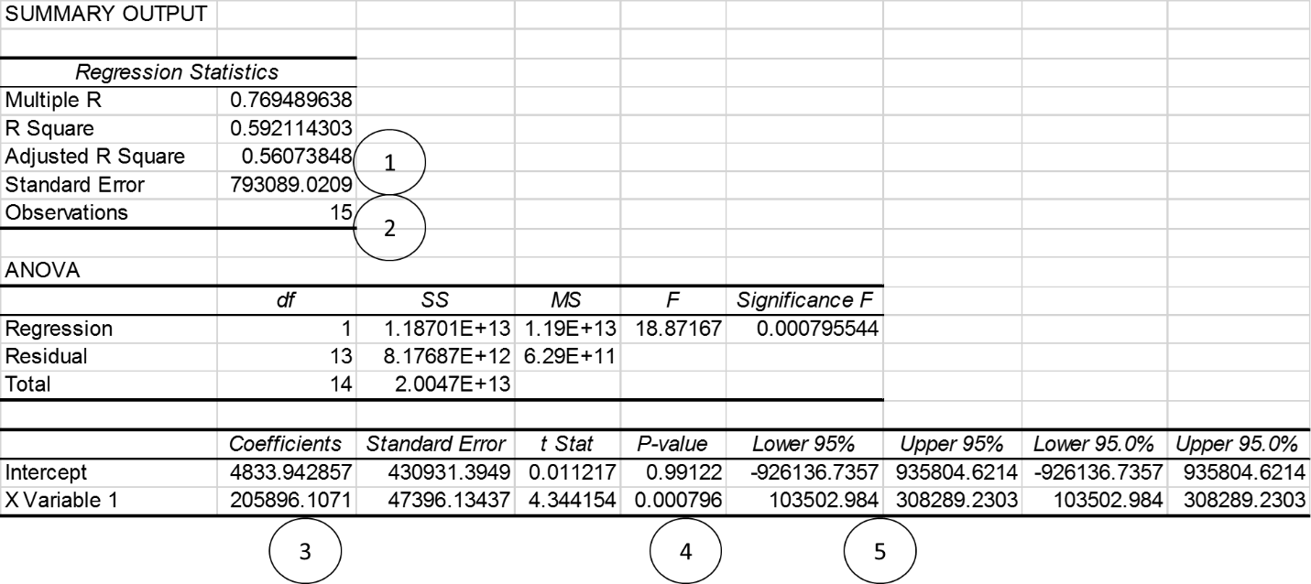
1. (2 Points) describe the two purposes of using a regression analysis in the business decisions.

2. (2 points) what can you measure if you use a regression analysis?
a. Pattern b. Trend c. Seasonality d. Irregularity
3. (2 points) take a look at number 1. Interpret 0.5607 (Do not simply say it is a measure of how close the data are to a regression line, and focus on the number)

4. (2 points) take a look at number 2. What does 15 mean in the table?
5. (2 points) what does an X variable (or Independent variable) in the table above measure? What does the Y variable in the table measure?

6. (2 points) take a look at number 3. Interpret 205896 (Do not simply say it is a slope, and focus on the number, and its unit is thousand)

7. (2 points) take a look at number 4. What does 0.000796 (P-value) indicate in the table?

8. (2 points) take a look at number 5. Interpret the lower 95% and upper 95% for X Variable at the bottom of the table. What does your interpretation indicate?

9. (2 points) write a formula for the relationship between X variable and Y variable.

10. (2 points) explain why we need the formula. For what?

